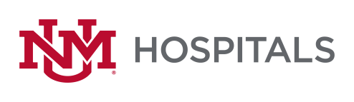

To: All Potential Offerors
From: Sherry Tackett, Procurement Specialist
Date: May 16, 2022
Subject: RFP P460-22 Urethral Bulking Agents
Please add this Addendum #2 to the original RFP documents. It shall be the responsibility of the interested Offerors to adhere to any changes or revision to the RFP as identified in this Addendum #2.

The following clarification shall become permanent and made part of the procurement file.

- Extend Due/opening date to 5/25/2022 at 2:00 PM MST

If there are any questions or inquiries in relation to this Addendum #1, Offerors may contact Sherry Tackett at (505) 272-2575 or by email at sltackett@salud.unm.edu.

