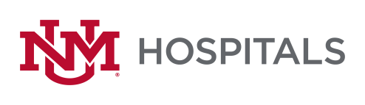

To: All Potential Offerors
From: Sherry L Tackett, Procurement Specialist
Date: 9/12/2022
Subject: RFP P470-22 Interventional Radiology Neuroendovascular Implants & Disposables
Please add this Addendum #3 to the original RFP documents. It shall be the responsibility of the interested Offerors to adhere to any changes or revision to the RFP as identified in this Addendum #3.

The following clarification shall become permanent and made part of the procurement file.
- Extending opening date until September 21, 2022 @ 2 pm MST

If there are any questions or inquiries in relation to this Addendum #3, Offerors may contact Sherry Tackett by email SLTaclett@salud.unm.edu.

